Remarks on the new website currently being redesigned at
https://alltoit.biz/development/logistics/

- Logo/Branding guide and website colors not followed: See blow
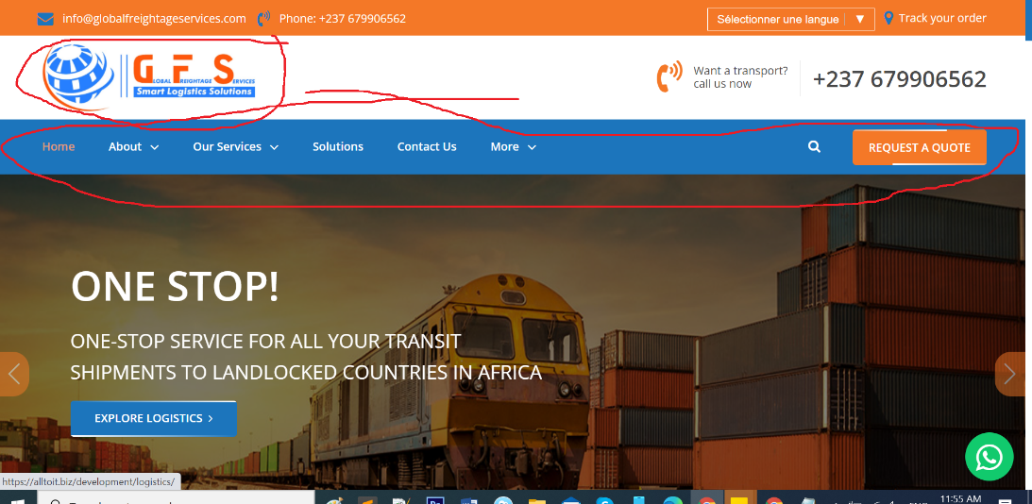
Advice: Kindly read/follow instruction on branding guide as well as use “The 90-30-10 rule”

- The language bar should be with flags and re-adjusted to the left top corner and phone numbers on the right top corner =>Done
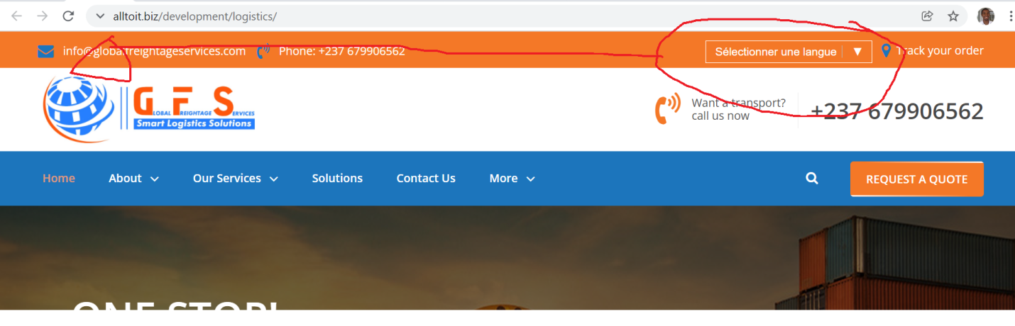
- The text/button or link “ Track your order” should be updated to “Tracking” => Done
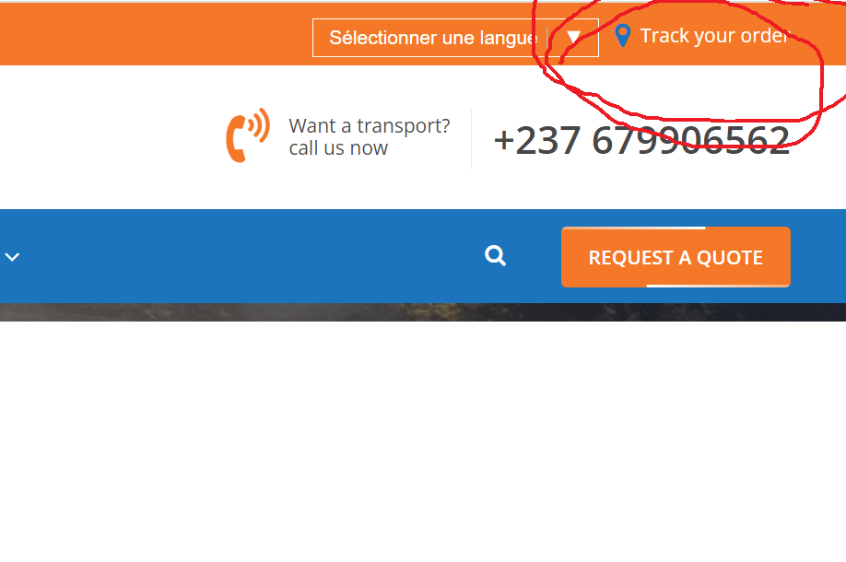

- The text/link/button request a quote should be up updated to “Quotation” => Done
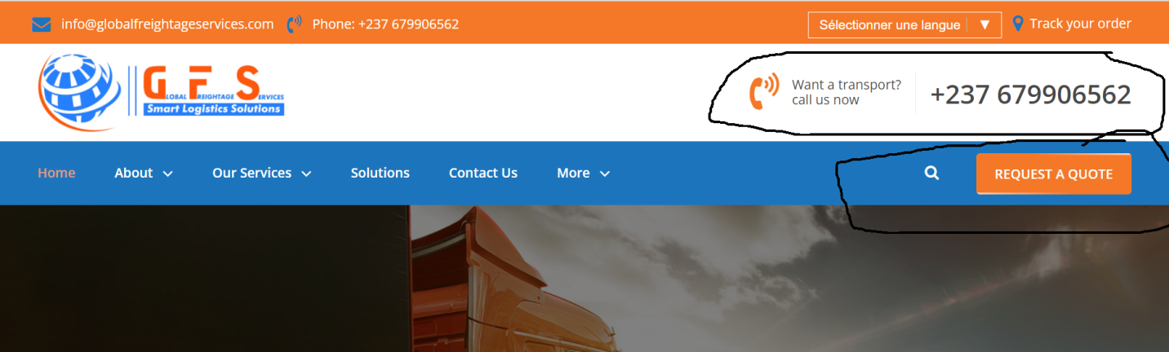

- The home page slider should have GFS Real images ( images of GFS in action) with Marketing/Sales call to action messages => Done
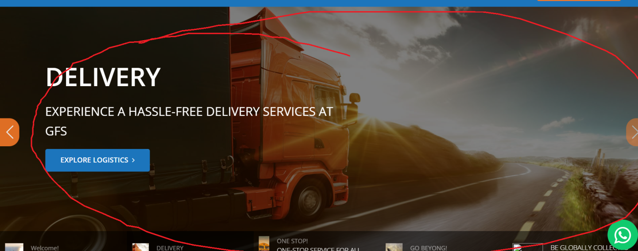

- The intro section of the home page be “ GFS At A Glance” with figures/facts about GFS
- You can manage this section from Supply Chain Management under the Home Section.

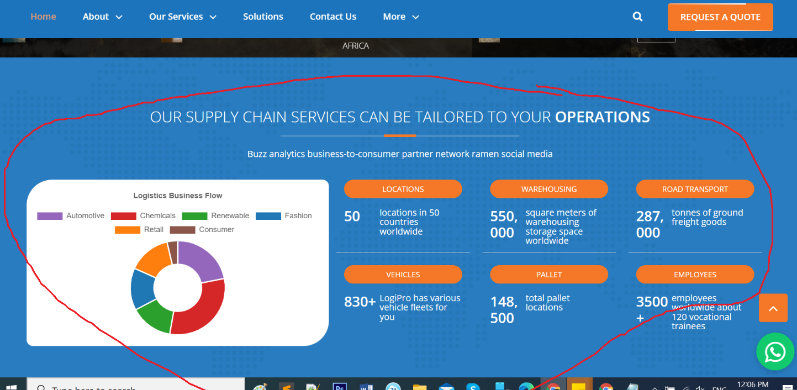

- The section of Our feature be updated to our services =>Done

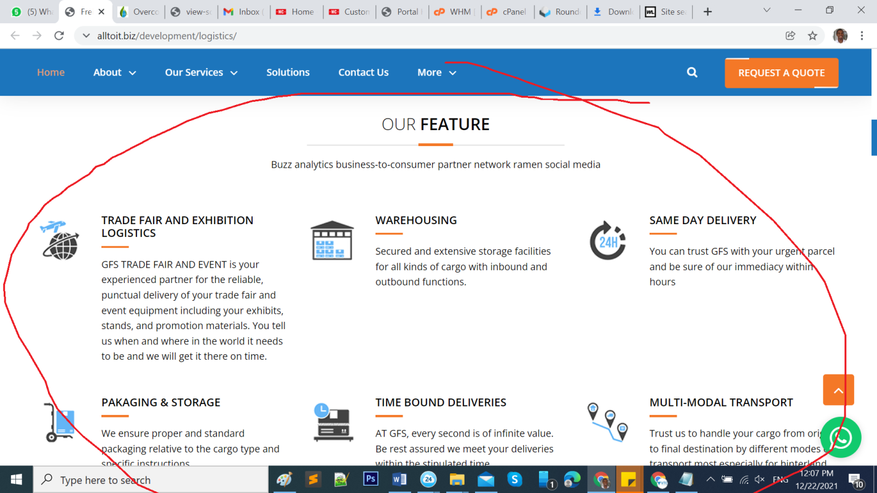

- Changes to be made under ‘Solutions’. =>Done

Below the page, the information highlighted can’t be found for editing on the background portal.
LOGISTICS INTERNATIONAL
Providing End To End Logistics & Cargo Solutions
Curabiturullamcorperultricies nisi.Nam eget dui.Etiamrhoncus. Maecenas tempus, tellusegetcondimentumrhoncus, sem quam semper libero, sit ametadipiscingsemnequesed ipsum.
- Option needed to edit the WhatsApp number on the background portal. => Done
- Customer service link is needed to be used on the FAQs questions that require one. (A link that takes web visitors directly to business@globalfreightageservices.com)
- A career page option is needed. Can be added below More =>Done
- Also an option for an online form for becoming an approved GFS carrier related to our FAQs.
- “Our work place’’ under “About’’ needs adjustment. It can’t be accessed nor edited from the Web page and background portal.
- Our work palace works same as gallery images.

- Under Home page, immediately before the bottom of the page, informations as;
Location
Warehousing
Road transport
Vehicles
Pallet
Employees
Option for editing is needed on background portal page. =>Done
- The website footer background color shouldn’t be black. It can be white. =>Done
- The newsletter option isn’t responsive =>Done
- The potion ‘design by’ below should rather be ‘Credit to’. =>Done
- Option for testimonial should be changing one at a time not two at same time and space occupied should reduce. =>Done
- Specify the number for direct call is a mobile number and indicate the days and hours of work (For GFS). => Added on top bar.
- Include option to edit or change video in the background portal. => Done
- You can change the video URL from Manage popup video.

- The video on web page should display at the right hand side of the page. => Done

